Notes papers

# Paper 1

## Summary

Besnard, Philippe, and Anthony Hunter. **"Constructing argument graphs with deductive arguments: a tutorial."** *Argument & Computation* 5.1 (2014): 5-30.

* Formalize deductive arguments that use montonic logic. Propose the following framework:

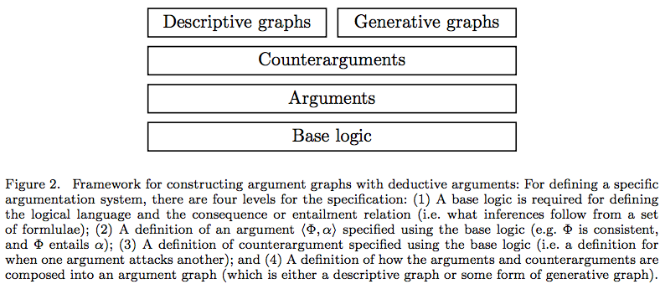

* A deductive arguments is a pair (A,b) where A is a set of formulas an b is a formula that is logically entailed form A.
* Logic may be any logic, but they study simple logic (Horn-like) and classical logic (FOL).
* The knowledge base may be inconsistent (otherwise there would be no attack relations).
* So the argument extensions may be non-monotonic, but the arguments are monotonic internally.
* An argument ({a&b->c,a,b},c) is accepted, but can be attacked by ({d->-b,-b,d},-b). Hence the nonmonotonicity.
* Two ways of constructing arguments: descriptive and generative. Descriptive seems interesting for us.
* **Description descriptive graphs:** For instance, when we listen to a debate on the radio, we may identify a number of arguments and counterarguments, and for each of these we may be able to write a brief text summary. So if we then want to understand this argumentation in more detail, we may choose to instantiate each argument with a deductive argument. So for this task we choose the appropriate logical formulae for the premises and claim for each argument (compatible with the choice of base logic).

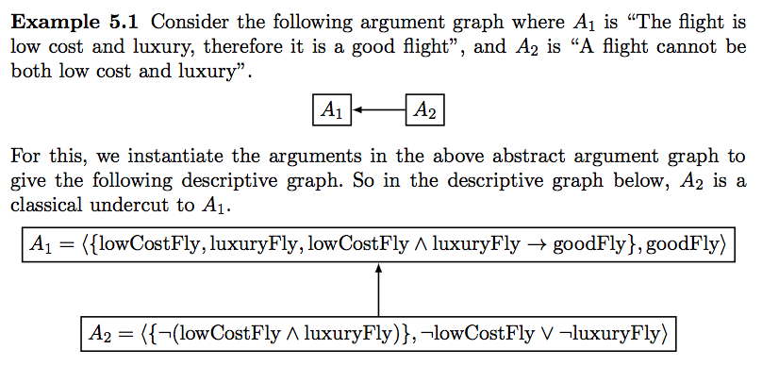

## Discussion

+ The descriptive graphs seem fitting with our problem domain. I can imagine stakeholders arguing vaguely about something first, only mentioning the main arguments and counter arguments, and then iteratively zoom in on the internal strcuture.

- There is no relation with arguing about goals yet. We know that arguing about goals (practical reasoning) is different from arguing about beliefs (reasoning). So this should probably be present in the formal theory as well.

# Paper 2

## Summary

Atkinson, Katie, and Trevor Bench-Capon. **"Action-based alternating transition systems for arguments about action."** *AAAI*. Vol. 7. 2007.

* Combine a formal framework for multi-agent normative reasoning with a theory from practical reasoning.
* They view practical reasoning as proceeding in three stages:

1. *Problem formulation:* deciding what facts, values, interests and aspirations are relevant in the particular situation;
2. *Epistemic reasoning:* Determining the current situation with respect to the structure formed at the previous stage;
3. *Action selection:* Developing the appropriate arguments and counter arguments, in terms of instantiations of an appropriate argument scheme, and evaluating the resulting set of arguments with respect to an ordering on the social values promoted by the arguments.

* Use the work of Atkinson who extended the argument schemes for practical reasoning. Atkinson developed the following argument scheme:

AS 1 In the current circumstance R

We should perform action A

Which will result in new circumstances S

Which will realise goal G

Which will promote value V.

There are 16 critical questions with this, such as

CQ1: Are the believed circumstances true?

* They then relate these critical questions to the three stages of the practical reasoning process.
* They formalize this in a normative framework by adding values. Example:

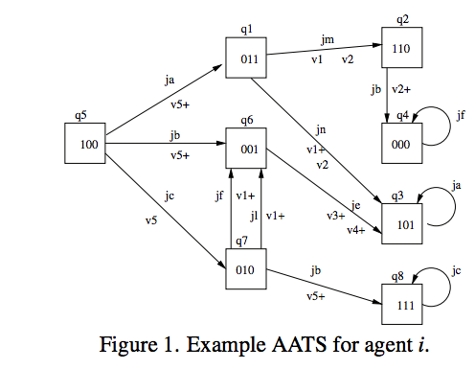

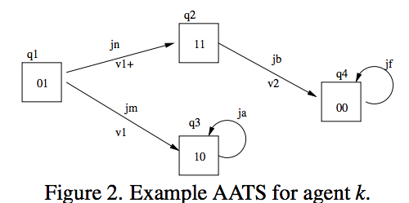

Here the states contain propositions true in each state. The main idea is that the agents then argue about the representation of these graphs using argument schemes. For instance, agent 1 believes that join action jn in q1 leads to q2 while agnet 2 believes it leads to q3. Then they can argue in the three phrases above.

## Discussion

How to relate this to goal modeling?

* In the normative framework, Each stakeholder has its own representation of the problem, which we can represent using the state transition diagrams.I think this is interesting, because it allows you to give different views on the same problem, a bit comparable to ArchiMate's views.
* Consider the following simple goal model:

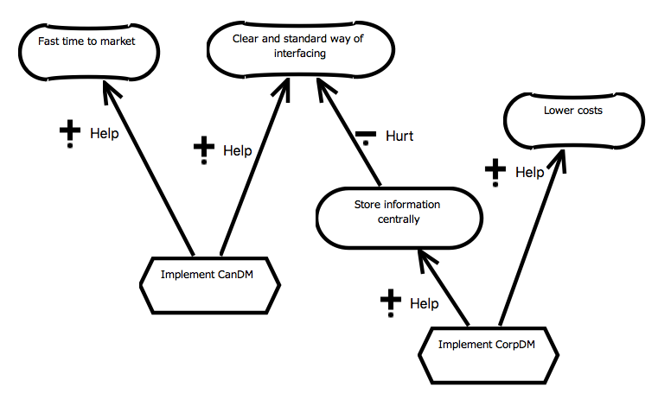

How to represent this in their framework?

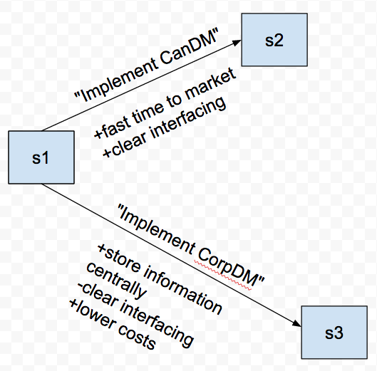

**1. Temporal dimension.**

They use a branching time logic, with a temporal ordering over joint actions.

In GRL, there is no ordering over actions. Rather, only dependencies between (soft)goals and actions are specified.

I think the main issue is in line 1 and 3 of the argument scheme:

AS 1 In the current circumstance R

We should perform action A

Which will result in new circumstances S

Which will realise goal G

Which will promote value V.

In goal models, there is no notion of planning. There is no state from which we perform actions, and a new state we end up with.

**2. Values.**

In their framework, action can promote or demote values, which seems to have some links with softgoal.

However, in GRL these values (softgoals) are decomposed into goals, which are again decomposed into tasks.

It is not completely clear to me how this decomposition element is formalised in their work.

So it seems to me that their framework is useful for a group of stakeholders that are planning a project. However, this seems already a step further than what goal modeling is about, namely to decide on what the actions, goals, and values *are.*

# Paper 3

Atkinson, Katie, and Trevor JM Bench-Capon. "**Taking the Long View: Looking Ahead in Practical Reasoning**." *COMMA*. 2014.

## Summary

They extend the previous paper by taking into account values for the long term using temporal logic modal operators such as G, X, F, etc.

## Discussion

Similar to the previous ones, they are doing planning, which we aren't doing.

# Paper 4

Atkinson, Katie, and Trevor Bench-Capon. **"States, goals and values: Revisiting practical reasoning."** *Proceedings of 11th Intl. Workshop on Argumentation in Multi-Agent Systems*. 2014.

To read

# Paper 5

Murukannaiah, Pradeep K., et al. "**Resolving goal conflicts via argumentation-based analysis of competing hypotheses**." *2015 IEEE 23rd International Requirements Engineering Conference (RE)*. IEEE, 2015.

## Summary

* This paper extends an approach to resolve conflicts between goals by adding argumentation techniques.
* So it only focuses on a very specific problem: What to do if two goal conflict.
* They extend the ACH (Analysis of Competing Hypothesis). This framework works as follows:

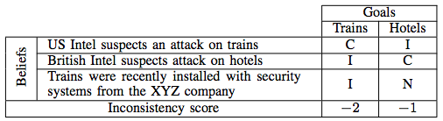

* You say for each belief whether it is consistent, neutral, or inconsistent for a goal. Then you count the inconsistency score.
* The extend it as follows:

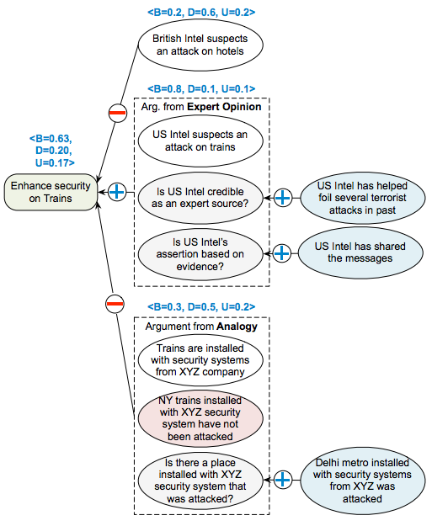

* So goals are supported (consistent) or attacked (inconsistent) by beliefs. These beliefs are arguments constructed with argument schemes. The critical questions are then attack points on the arguments, which can be answered negatively or positively.

## Analysis

* They also use argument schemes, although theirs aren't as sophisticated as the ones we intend to use. They just seem to use any arbitrary version of argument. It is not clear to me how a requirements engineer should decide which argument scheme to use when.
* What is nice about their approach is that they are able to agglomorate evidence. So you can have some evidence for and some evidence against an arguments, and then you decide based on the strength of the argument.
* Their approach can only be applied to a very limited subset of goal modeling, namely to decide whether a goal should be part of the goal model or not. There is no argumentation about other elements, or about links.
* They also don't make this link with goal modeling explicit, and they also don't seem to have implemented it into a goal modeling tool.

# Paper 6

Hassine, Jameleddine, and Daniel Amyot. **"A questionnaire-based survey methodology for systematically validating goal-oriented models."** *Requirements Engineering* 21.2 (2016): 285-308.

## Summary

* 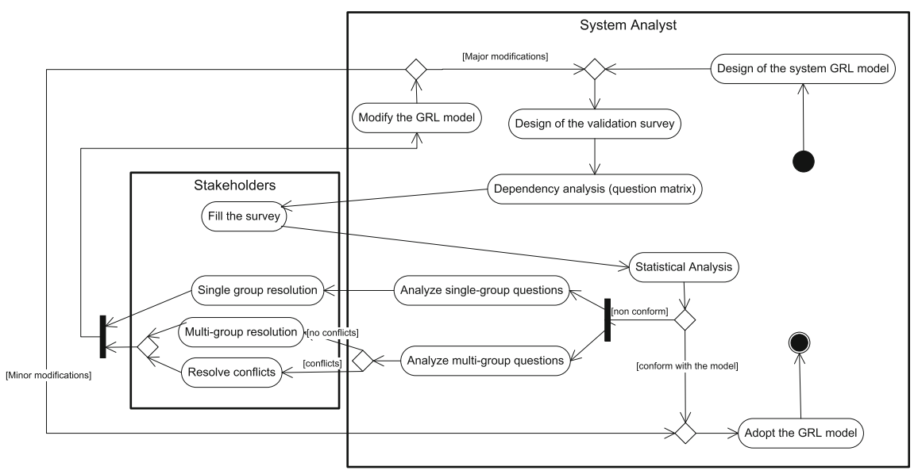The authors propose the following GRL validation approach.
* The idea is that stakeholders fill in a survey in order for the requirement engineer to analyze whether they agree on elements of the goal model. This can have different results: They agree with the goal model, they do not agree with the goal model but with each other, or they do not agree with the goal model and also not with each other.
* The questionnaire looks for instance as follows:

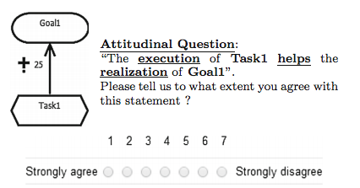

## Analysis

* The questions are somewhat like critical questions, but they are very direct. It seems that stakeholders can only agree with or disagree with an element or link, but they cannot propose alternatives, etc. This is possible with critical questions.